THE SCHILLING SCHOOL FOR GIFTED CHILDREN
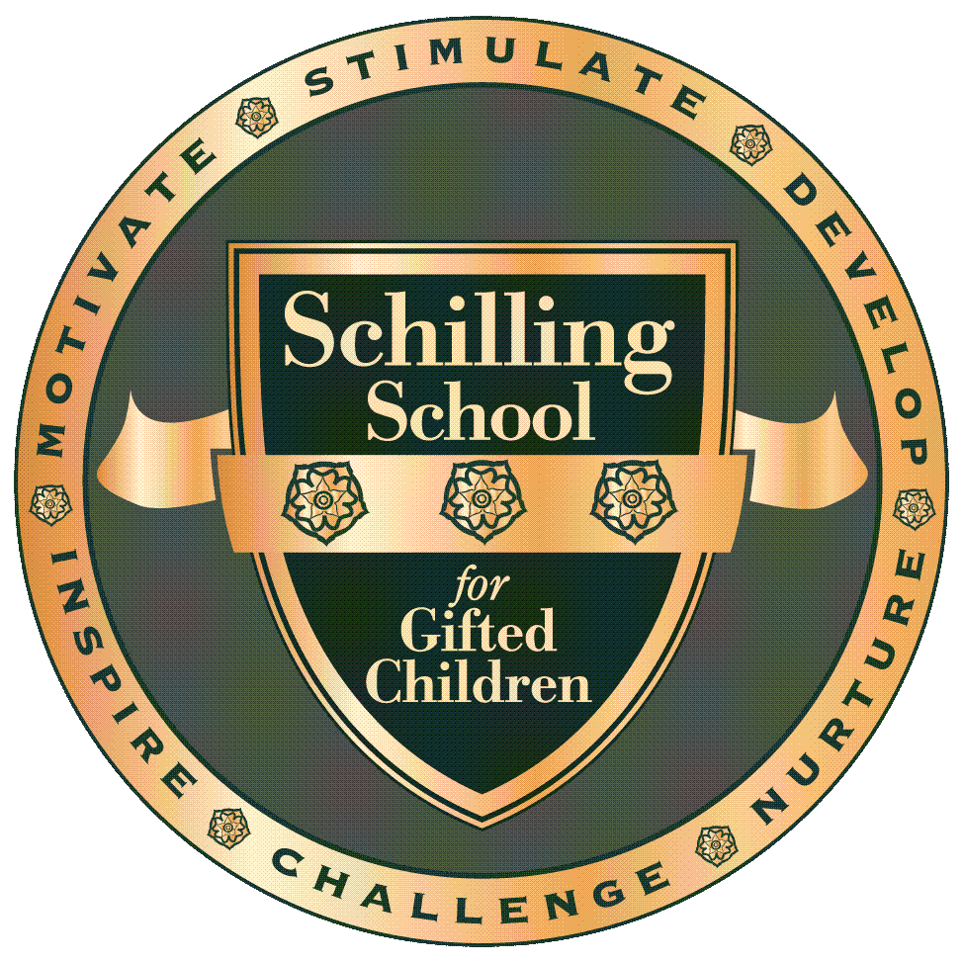
8100 Cornell Road
Cincinnati, Ohio 45249
513-489-8940
ENROLLMENT APPLICATION

Date of Application
Grade Male Female
Birth Date Age

Student’s Full Name I.Q. ( )
First Middle Last Name Preferred by Student

Student’s Home Address ( )
Street City State Zip Home Telephone Number

E-mail Address

Public School District of Current Residence

Father’s Full Name Business Telephone

Father’s Occupation
Title Name & Address of Employer

Mother’s Full Name Business Telephone

Mother’s Occupation
Title Name & Address of Employer

Father’s/Mother’s Home Address (if different from student)

If parents are separated or divorced, indicate with whom child lives:

Maternal Grandparents Address Zip Code

Paternal Grandparents Address Zip Code
Other Children in the Family (use back if you need more room)
Name Age School

Does your child have any special needs of which we should be aware?
(Use back if you need more room)

How did you find out about The Schilling School for Gifted Children?

Why do you want your child to attend?

Signature of Parent or Legal Guardian
NONDISCRIMINATION POLICY
The Schilling School for Gifted Children, Inc. recruits and admits students of any race, color, or national or ethnic origin to all the rights, privileges, programs and activities. In addition, the School will not discriminate on the basis of race, color, or national or ethnic origin in administration of its educational policies, scholarships/loans/fee waivers, educational programs and athletics/extracurricular activities. In addition, the School is not intended to be an alternative to court or administrative agency ordered, or public school district initiated, desegregation. The Schilling School for Gifted Children, Inc. will not discriminate on the basis of race, color, sex, age, religion or national or ethnic origin in the hiring of its certified or non-certified personnel.

