Dear Schilling Community,


My name is Daniel Frank, and I am delighted to serve as President of the Schilling School Interact Club for 2015-2016. Sponsored by Rotary International, Interact focuses on community and international service projects.
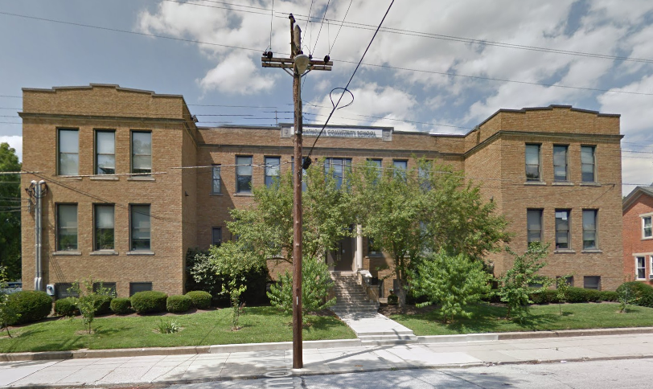
Our Club has identified a local non-profit organization that would significantly benefit from our support—Lighthouse Youth Services (LYS). LYS advances the dignity and well-being of children in families that are socially or economically struggling (e.g. children that have had a bad upbringing, scary home lives, victims of crime, etc.). They even have their own school to help educate these children!
LYS provides these services solely by means of donations. They provide Christmas presents for all of their children, and they are currently in need of supplies. This year, we've decided to give them a hand.
Lighthouse Community School provides education for those in need and helps to bring them back into their community
What They Need:
Clothing School Supplies Cleaning Supplies
Linens Kitchen Items Baby Items
Bottled Water Hygiene Supplies Blankets
You can help us with this effort by purchasing supplies from the above list or donating money, and we'll do the shopping! We will be delivering on December 18th, so please bring donations to us by December 11, 2015 and place them in the designated spot in the lobby.
Thanks in advance for your support of the Schilling School Interact Club! This is going to be a great year!
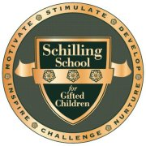
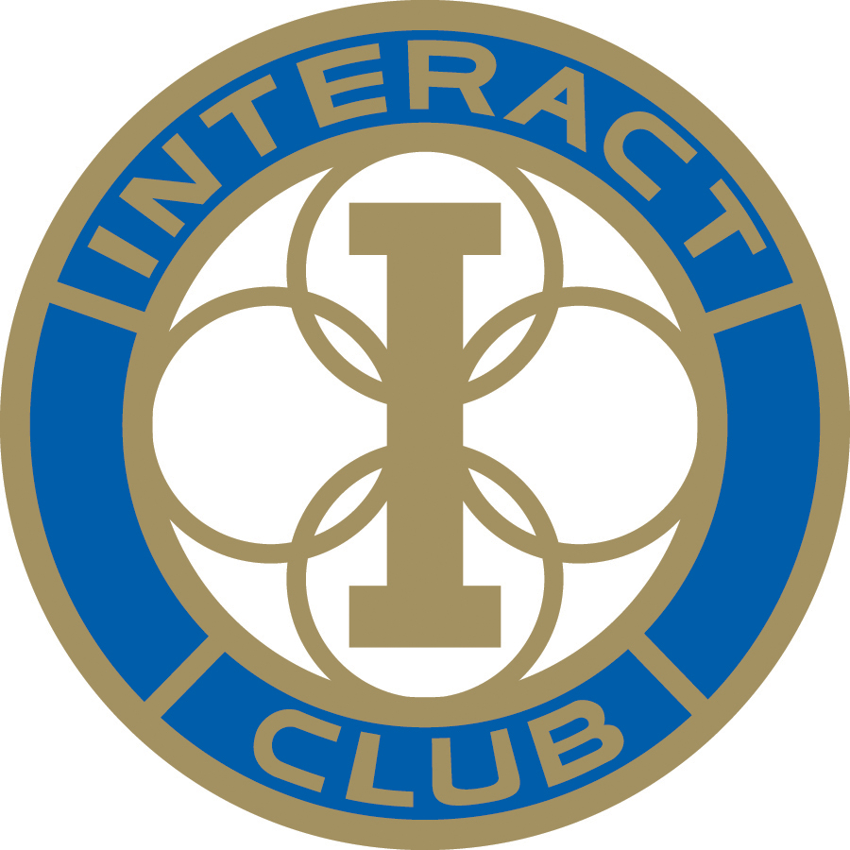
Sincerely,

Daniel Geauwanna Frank

